Handling Social Pressure

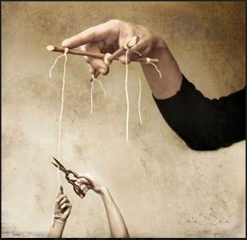

#1
Pirkei Avos 2:13
...which is the proper path to which a person should cling? Rabbi Eliezer says: A good eye. Rabbi Yehoshua says: A good friend. Rabbi Yossi says: a good neighbor...
Pirkei Avos 2:14
...which is the evil path from which a person should distance himself? Rabbi Eliezer says: An evil eye. Rabbi Yehoshua says: A wicked friend. Rabbi Yossi says: a wicked neighbor...

Question: How can a friend or neighbor be the answer for a proper or evil path?

#2
Pirkei Avos 1:6
Establish a rabbi for yourself, acquire (buy) a friend for yourself, and judge every person favorably.
Pirkei Avos 1:7
Distance yourself from a bad neighbor, do not associate with a wicked person, and do not despair of retribution.

Question: These two statements seem to parallel, complement each other. Do you see any connection?
#3
The Torah extensively details the set-up of the camp of Israel when they travelled in the desert.
We learn of the configuration of the camps of Israel that surrounded the Mishkan, the Tabernacle, on all four sides.
Torah, Bamidbar 3:29
The families of the children of Kohath were encamped…to the south...
Rashi
The families of the children of Kohath were encamped to the south: Near them was the division of Reuben, who camped to the south. Woe to the wicked, woe to his neighbor! This explains why Dathan, Abiram, and two hundred and fifty men were smitten with Korach and his congregation, for they were drawn into the dispute along with them.

Torah, Bamidbar 3:38
Encamped before the Tabernacle to the east…were Moses, Aaron and his sons...
Rashi
Moses, Aaron and his sons: It is good for the righteous one, and good for his neighbor. Because the tribes of Judah, Issachar, and Zebulun were neighbors of Moses, Aaron and Aaron’s sons, who were deeply involved in the study of Torah, they were all positively influenced to become great in Torah.

Rambam, Hilchos De’os 6:1-2
1. It is natural for man’s character to be drawn after the thoughts and actions of his friends and associates, and for him to follow the norms of the people of his country. Therefore, one must associate with the righteous and be constantly in the company of the wise, so as to learn from their deeds. Conversely, he should keep away from the wicked who walk in darkness, so as not to learn from their deeds. This is what Shlomo said “He who walks with the wise will become wise; he who walks with the foolish will be destroyed (Proverbs 13:20); and what is said “Happy is the man…”(Psalms 1:1)
2. A person who lives in a place where the norms of behavior are evil and the inhabitants do not follow the straight path should move to a place where the people are righteous and follow the ways of the good. If all the places with which he is familiar and of which he hears reports follow improper paths, as in our times, or if he is unable to move to a place where the patterns of behavior are proper, because of [the presence of] bands of raiding troops, or for health reasons, he should remain alone in seclusion, as is said “Sit alone and be quiet” (Eicha 3:28). If they are wicked and sinful and do not allow him to reside there unless he mingle with them and follow their evil behavior, he should go out to caves, thickets, and deserts [rather than] follow the paths of sinners as it states: "Who will give me a lodging place for wayfarers, in the desert." (Jeremiah 9:1)

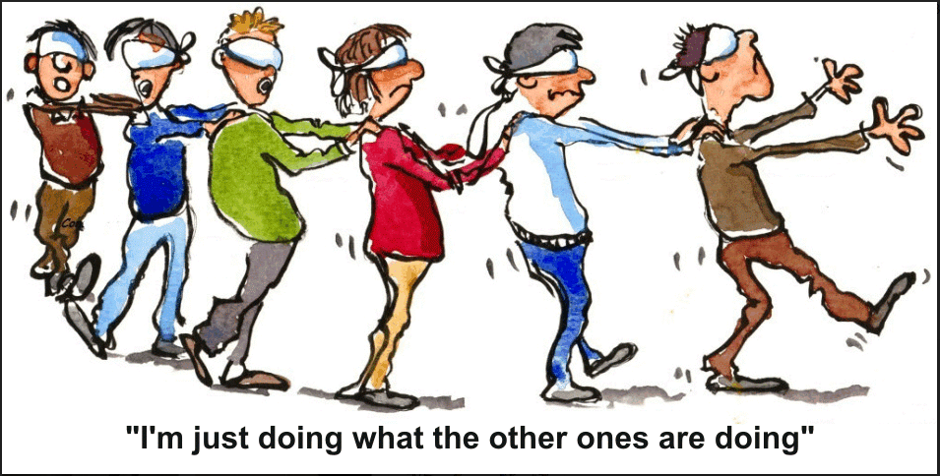

#4
Question: Is “everyone does it” a good approach in life? Explain why!

#5
Question: If you know something to be true but no one is on the same page with you -
(a) How does it feel?
(b) How would you go about it?

#6
Question: How do you combat social pressure?

#7
Question: How do you explain the psyche that people become followers of wild leaders like Hitler, Stalin etc.?

#8
Question: How to do the right thing without attracting social animosity when you obviously swim upstream?

#9
Question: What is your takeaway from today’s discussion?

